GANDAKI COLLEGE OF ENGINEERING AND SCIENCE
Internal Examination
Level: Bachelor | Semester: Fall | Year: 2023
Programme: BE software |  | Full Marks: 100
Course: Microprocessor and Computer Architecture |  | Pass Marks: 45
 |  | Time: 3 hrs
Candidates are required to give answers in their own words as far as practicable. Figures in the margin indicate full marks.
Attempt all the questions:
1. | a) | Define the terms: Microprocessor and Microcontroller. Differentiate between Von Neumann Architecture and Harvard Architecture. | 7
 | b) | Explain, in brief, the 8085 microprocessor with its block diagram. | 8
2. | a) | Write an assembly language program for 8085 MP to add two 8-bit numbers (F1 and 15), stored at C050H and C051H, with carry. | 7
 | b) | What is instruction cycle and machine cycle? Draw timing diagram for the instruction MOV A, B. | 8
3. | a) | How 8086 MP is advance than 8085 MP? Explain the addressing modes in 8086 Microprocessor. | 7
 | b) | Design a very simple CPU, with its state diagram, register section and ALU, for the given set of instructions.  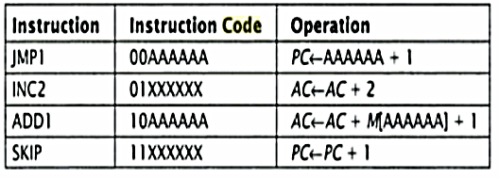 | 8
4. | a) | Design hardwired control unit for the CPU described in question 3b. Also, briefly explain its operation. | 7
 | b) | Design a micro-sequencer control unit with horizontal microcode for the CPU described in question 3b.  OR  Differentiate between:  - Horizontal microcode and Vertical microcode  - Hardwired CU and Microprogrammed CU | 8
5. | a) | Define RTL. Write the RTL codes for Booth’s algorithm. Trace with RTL to multiply -12 and 4. | 7
 | b) | What is memory hierarchy? Discuss briefly on different cache mapping techniques. | 8
6. | a) | What is the significance of DMA? Explain its working phenomenon with a block diagram. | 7
 | b) | Explain Instruction pipeline with an example. In a system, there are 5 register windows. Each of the window has 4 input register and 4 output register and 10 local registers. The system has 20 global registers. Calculate the total no. of registers. Show the pictorial representation of this register windowing architecture.  OR  What is Flynn’s taxonomy? Explain UMA and NUMA architectures. | 8
7. | Write short notes on: (any two) |  | 2x5
 | a) | Micro-sequencer
 | b) | Floating point number representation
 | c) | UART
 | d) | Multicore architecture

***

